How to Optimize Your Cell Isolation Method for Best Results

Posted by Luke Doiron on Jun 4, 2015 8:00:00 AM

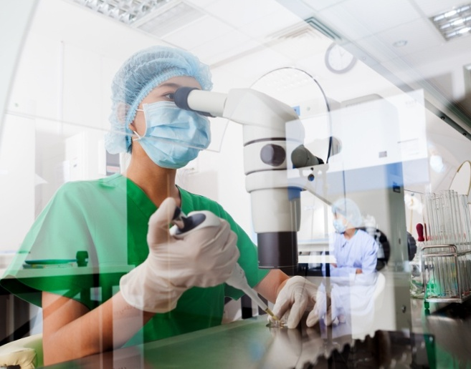
The goal of cell isolation is to maximize the yield of high-viability dissociated cells for a variety of scientific applications, including tissue culture and cell biology research. There are many, many protocols for this process, because of the wide variation in desired endpoint, type of tissue, and required dissociation enzyme(s). So while we can't offer a simple optimization method, we can point out a few key factors that play a role in optimizing your specific cell isolation program.

Consider your tissue type
Different tissues require different types of dissociation enzymes because of their cellular structure and the difficulty, or lack thereof, of separating primary cells from tissue bonds. For example, literature tells us that epithelial cells (including the epidermis, outer corneal layer, blood and lymph vessels) are usually packed very tightly together, with minimal intercellular material between. This tight bond makes it challenging to dissociate epithelial cells.
Connective tissue is widespread in the human body, arising from mesenchymal cells. It ultimately forms structures including the skin dermis, sheaths of neural and muscular cells, stroma and capsules of several organs, ligaments and adipose tissue. Connective tissue is made up of a variety of cells that may be loose or dense, depending on associated fibers, and include important cells for immunology, disease and drug discovery research - i.e. lymphocytes, monocytes, neutrophils, and mesenchymal cells.

Consider your choice of dissociation enzyme(s)
Many types of enzymes have been discovered for primary cell isolation protocols, based on where they cleave cellular bonds, and their specificity for certain bonds. This is an absolutely critical step in your cell isolationmethod, so pay particular attention to the type of enzyme you use, and its concentration.
- Collagenase is a widely-used enzyme because of its ability to degrade the triple-helical collagen fibrils found in connective tissue. While this enzyme historically was somewhat crude (i.e. had a mix of enzymes with a variety of effects), today it is available commercially in four types that are targeted for specific types of cells.
- Papain is another widely selected enzyme that has been shown to be very effective in isolating high yields of neuronal materials from a variety of tissues, both human and non-human. It is described as having wide specificity and the ability to extensively degrade most protein substrates. Papain is frequently used for preparing Fab fragment. This research on triple-negative breast cancer used papain to isolate Fab for same-day PET imaging and better disease management.

Research and select desired enzyme concentration, temperature and incubation time.
These are variables that should be tested and refined to achieve the highest cell yield and viability. You may need repeated tests to optimize cell isolation.

Quantitate and compare outcome
You won't know if your method is effective unless you perform a post-protocol quantitation of cell yield and viability, and then compare these results among protocol variations.

Basic isolation protocol

According to one of the leading commercial providers of cell isolation systems, here is a basic primary cell isolation protocol:
- Mince or cut isolated tissue piece into 2-4 millimeter pieces with sterile scissors or scalpel (for non-perfusion).
- Add tissue pieces to the appropriate buffer or balanced salt solution on ice and wash two to three times.
- Add appropriate amount of enzyme(s) and incubate at optimized temperature (typically 37° C, though this can vary). Mix intermittently.
- Gently disperse cells by trituration, taking care not to handle too aggressively.
- Filter cell suspension using fine mesh.
- Allow cells to settle and remove excess liquid containing digestive enzymes. Wash and repeat two to three times.
- Resuspend cells in appropriate medium/buffer.
- Quantitate cell yield and viability.

